Ideation Phase
Define the Problem Statements

Date | 02 October 2026
Team ID | SWTID-2026-8115
Project Name
Maximum Marks | 2 Marks

Customer Problem Statement Template:
Auto Ticket Classification using Flow Designer focuses on delays and inconsistent routing that can happen when support tickets are categorized manually.
The statements below describe the service desk agent and employee perspectives. They guide a Flow Designer solution that applies configured rules and leaves unclear cases available for human review.
A well-articulated problem statement helps the team understand the employee and service desk agent challenges that Auto Ticket Classification using Flow Designer should address.
Reference: https://miro.com/templates/customer-problem-statement/
Problem statement examples for ticket classification
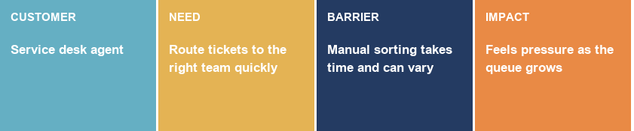
Problem Statement (PS) | I am (Customer) | I’m trying to | But | Because | Which makes me feel
PS-1 | a service desk agent | route incoming support tickets to the right team quickly | manual categorization takes time and results can vary between agents | ticket descriptions may be incomplete and queues can be busy | pressured by delays and concerned about missed service targets
PS-2 | an employee reporting an IT issue | get help from the team best suited to resolve the issue | a ticket may be assigned to the wrong support group | category and assignment are selected manually from the issue details | uncertain about when the issue will reach the right team

